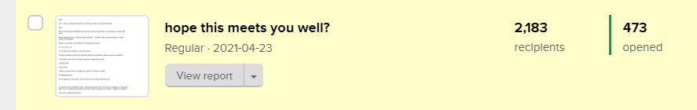
473 people opened this email: https://preview.mailerlite.com/l3g9g0
-------------------------------------------------------------------------

Headline: hope this meets you well?
———————————————-

Dear {&name},

LOL! I mean, I do hope this meets you well, but you know I never write that way.

Why?

Because that’ll signal DANGER! (lamide wants to ask for my kidneys or something I can’t give right now).

When people send me “I hope this meets you well” - I wonder if they read that sentence out loud, exactly as it's written?

Doesn’t it sound like a robot failing at sounding like a human?

It’s a turn off for me.

If you really want something - You’ll flirt with me.

The best messages I get are the ones that start with compliments. Now you've got my attention!⠀

I even love it more when the sender makes the compliment specific.

Something like;

“Hey Lamide,

I follow your work and it has taught me more than I thought I needed!

I'm writing because…”

You’ve gotten me in the mood - you can have my atm cards at that point. 😀

-

IG-Spammer-with-2-followers: “Hello. I hope this finds you well. I see that your instagram isn’t growing fast. I’m an IG Growth Expert based out in the US that can get you more reach. I await your response.”

First of all, I get them all the time.
Secondly, a growth expert with 2 followers? LMAOOO!

No thank you. Block-and-Delete!

How do you start a message when you want something? Hit reply and tell me.

Lamide.

